UPSC Pods: Marketing Plan to 1M Downloads
Oct 10, 2026 · @Edureka

Summary
UPSC Pods reaches 1M Play Store downloads by December 2027 by making members the marketing: pods that fill by invitation, share cards people actually want to post, and daily Chai content that doubles as short video. Paid ads carry only 15% of the target and run only in three exam windows.
- Goal: 1M cumulative installs by 31 Dec 2027, with at least 20% of installs still active at day 30 and a Play rating of 4.5 or higher.
- The core bet: win on belonging and honesty, not content volume. No other UPSC app is a moderated small-group home with no hype (founding brief, section 7.2).
- The honest maths: about 10 lakh people apply for CSE each year. 1M downloads means reaching almost every serious UPSC aspirant plus the wider pool of state PSC aspirants and UPSC-curious graduates. That is why Hindi parity and state PSC pods are in this plan from launch, not later.
- The calendar does the timing: the CSE 2027 notification (13 Jan 2027), Prelims (23 May 2027) and the Prelims result (about mid-June 2027) are the three moments when aspirants look for help. Most spend and effort land there.
- Budget: about ₹1.45 crore over 15 months, roughly ₹14.5 per install blended (approximate, see Budget).

Who we are for
Lead with Cohorts A and C, the largest groups with the most time before Prelims 2027, and treat repeaters and Hindi-medium aspirants as first-class from day one.
Segment | Rough size | What they feel | What brings them in | Where to reach them
A. Prelims 2026 non-qualifiers restarting | about 5 lakh | Grief, no score feedback, "go again?" | A restart pod, honest diagnosis, company | Reddit, Telegram, YouTube, after the 72-hour quiet period
C. Fresh starters for 2027 | large, peaks at notification | Overwhelm, resource paralysis | Today's 3 tasks, 5-source maps, a pod of peers at the same stage | Shorts and Reels, college campuses, ASO
B. Mains 2026 takers awaiting results | about 13,000 | Anxious limbo | A calm waiting room | Telegram, Discord, word of mouth
D. Long-haul repeaters (4th+ attempt) | small, high influence | Fatigue, shame, sunk cost | Respect, Plan B without judgement, a role as pod lead | Reddit, direct invites
State PSC and UPSC-curious graduates | several times the UPSC pool (inferred) | Same grind, fewer resources | Hindi Chai cards, state PSC pods | Moj, Josh, WhatsApp, YouTube in Hindi
Parents (influencers, not users) | one per aspirant | Worry, "what's the plan?" | The Parent page a member sends home | WhatsApp forwards
Personas from the brief map onto these: Arjun and Kavya (Hindi-medium, Tier-3, low-end phones) sit mostly in A, C and state PSC; Meera in A; Rahul (working professional) in C; Vikram in D; Sana across all, with privacy needs that shape every share feature. Sizes for A, B and the total applicant pool come from section 1 of the founding brief; the state PSC size is an inference to verify.

Positioning and brand voice
UPSC Pods is the honest, moderated home where you never prepare alone. Every message we put out should sound like a senior who has been through it, not a coaching ad.
Positioning line: "The only UPSC app that tells you the truth, and doesn't let you do it alone." Hindi: "सच बताता है, और अकेला नहीं छोड़ता।"
Four proof points we repeat everywhere:
- A pod of 8 to 10 people at your attempt and stage, with a human lead.
- Today's 3: five Chai cards, five Prelims questions, one Mains answer. Then you're done.
- News notes checked by a human editor, in English and Hindi, with sources on every card.
- Free forever: pods, Today, rooms, calculators, helplines. No upsell on result days.
Voice: warm, plain, bilingual, a little funny on light days. Hindi copy is written in Hindi, not translated after the fact.
What we never say or show:
- Rank, selection or "crack UPSC" guarantees, or any result claim we cannot prove.
- Countdowns, "last chance", fake scarcity, or a streak number. The app replaced streaks with a private weekly rhythm, and marketing follows.
- Toppers' names or photos without written consent.
- Fear statistics used to scare ("1 in 540 make it"). Odds appear only inside honest tools that help people plan.
- Mental health as a hook. Helplines and the distress check are a promise we keep, not an ad angle.
- Inadequacy copy such as "Falling behind?" or "Toppers know what you don't". The aspirant is the hero and the app is the mentor.
- Photos or voices of real thinkers without written permission, and never an AI voice imitating anyone. We credit Kahneman, Oakley and others by name and point people to their books, without suggesting they endorse us.
- Health claims for calm tools. Binaural tones and breathing are "something some people find relaxing", never therapy, and never a substitute for the helpline.
- Unchecked or fake quotes, or any thinker used as a political or religious mascot.
- Any suggestion that we are affiliated with UPSC. Every listing and creative carries "Not affiliated with UPSC" (see Risks: the app name itself needs a check).

Funnel math to 1M downloads
The 1M splits across seven channels, and 850k of it must come from channels we own. That only works if each active member brings in about 0.3 new installs and day-30 retention holds at 20%.
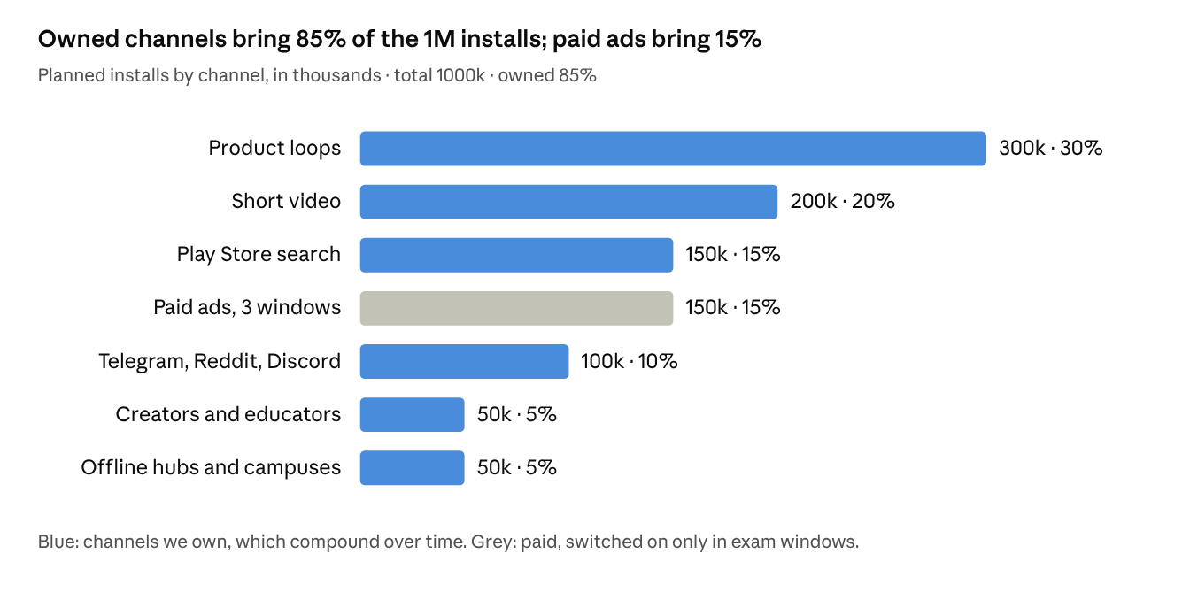
Planning targets set in this plan, not measured data · Oct 2026 to Dec 2027
Working backwards: 1M installs at 20% day-30 retention leaves about 200k active members, in roughly 20,000 pods with 2,000 pod leads. Lead supply, not ad spend, is the real ceiling, which is why the paid line is capped by how many leads and moderators are in place (see Retention and Risks).

Phased roadmap
Five phases, each with a gate that must pass before spending more. Growth is fastest around the three moments aspirants look for help: the notification, Prelims, and the Prelims result.
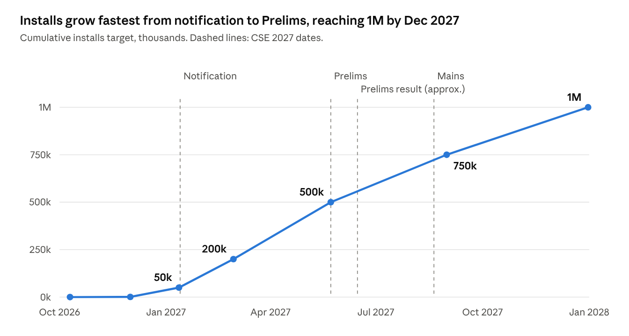
Targets set in this plan; exam dates from the UPSC calendar in the founding brief
- Founding (now to end of November 2026). Closed test with 12 testers for 14 days, then 300 hand-recruited founding members in 30 pods, with Ashok Nagar as the first offline hub. Start the Telegram channel, the daily Chai of the Day card and the Ek Minute reels. Gate: day-7 active of 30% or higher among founders, distress protocol tested, helplines test-called.
- Public launch (December 2026 to 12 January 2027), 50k. Play listing in Hindi and English, Mains 2026 result waiting room, first 20 creators, campus ambassadors. Gate: Play rating 4.3 or higher and pods with an active lead at 90%.
- Notification wave (13 January to February 2027), 200k. First paid window, "Start 2027 with a pod" campaign for fresh starters, state PSC pods open. Gate: day-30 active of 20% for the January cohort.
- Prelims run-up and restart (March to August 2027), 750k. Second paid window before Prelims; the State of the Aspirant report; after the result, 72 hours of quiet, then the Restart campaign and the third paid window, the biggest acquisition moment of the year. Gate: lead and moderator capacity keeps pace with installs.
- Mains and the 2028 cycle (September to December 2027), 1M. Mains companions, 2028 starters and a second state-PSC push. No paid window; growth comes from loops, video and search built up over the year.

Notification-day wave plan (13 January 2027)
The CSE 2027 notification is the year's first big moment and the start of the first paid window. The aim is 50k to 200k installs between 13 January and the end of February. The wave is framed as a fresh start, never a deadline: no countdowns, no "last chance", and no guesses about vacancies before the official notice is out.
When | What happens | Where | Owner
15 Dec to 31 Dec 2026 | Recruit and train about 3,000 more pod leads from founders and early members. At 20% day-30 retention, 200k installs means about 40,000 active members, or 4,000 pods of 10, each needing a lead. Pre-build 300 "forming pods" for fresh starters and state PSC aspirants. | App, pod-lead playbook | Community lead
1 Jan 2027 | New Year as a fresh start: the routine builder push, "Start 2027 with a pod" posts. | Instagram, WhatsApp Channel, Telegram, website | Social editors
12 Jan (evening) | Pod leads share "What to check in tomorrow's notice": eligibility, attempts, age, documents. | Pods, Telegram | Pod leads
13 Jan, as soon as the notice is out | An editor-checked Chai card on what the notice actually says, in Hindi and English. The attempts and age calculator is updated to the official rules the same day. Nothing goes out before the official PDF is read. | App, website, Telegram | Hindi and English editors
13 Jan, 19:00 to 22:00 | A live "form-filling room" where pod leads answer questions together. | App Rooms, Discord | Pod leads
13 Jan onward | The first paid window opens: Google App Campaigns and Meta in Hindi and English, optimised for a first Close the Day. Creators post (10 in week 1, 20 by week 3), every post marked as paid. | Play, Instagram, YouTube | Performance marketer
14 Jan to 1 Feb | Campus ambassadors run form-help desks in partner libraries and colleges. Offline QR pop-ups at Ashok Nagar, Mukherjee Nagar, Old Rajinder Nagar, Prayagraj, Patna. | Offline | Campus leads
2 Feb (applications close) | One calm reminder, only to members who asked for it: "Applications close today. Here's the checklist." | App notification (opt-in) | Community lead
3 Feb to 28 Feb | Settle in: first pod calls, first Wins of the week, a day-30 check of the January cohort before the next spend. | App | Community lead
Gates for this wave: pause paid spend if pods without an active lead go above 10%, or if distress-post reply times slip past the published hours. Notice details (dates, vacancies, rules) are copied only from the official notification and checked by an editor before they're posted.

Channels and playbooks
Seven channels, each with one job. The first three are owned and compound over time; the last two are bought and switched on only in exam windows.

1. Product loops (300k installs)
- Pod invites: a new pod opens with 3 to 4 matched members and 4 to 6 empty seats. "Invite a study friend" fills them, and a friend joins your pod rather than a random one.
- Share cards: the Chai of the Day status card, plus opt-in Wins and calculator result cards. Nothing from pods, Close the Day or mood is ever shareable. Each ends with the app name and a Play link, and none shows a rank or a streak count.
- Parent page: a one-tap WhatsApp share that explains the aspirant's week to family in Hindi or English. It reaches the person who often pays.
- Referral reward = pod perks: extra answer feedback for the whole pod, never cash.

2. Short video (200k installs)
- Three "Ek Minute" explainers a week (45 to 60 seconds, captioned) and the daily Chai of the Day status card, in Hindi and English, on YouTube Shorts, Instagram Reels, Moj and Josh.
- Weekly formats: Teesra Attempt people stories, a map or timeline story, study-with-me streams set to the content plan's study soundscapes, Resource Court (keep or skip a popular book), Honest odds explainers, and a Friday light quiz.
- One founder-led channel in Hindi. Faces and voices of real members, with consent, outperform a logo.

3. Play Store search and listing (150k installs)
- Separate Hindi and English listings. Target searches such as "UPSC current affairs Hindi", "UPSC daily quiz", "UPSC study group", "IAS preparation app", "करेंट अफेयर्स हिंदी".
- Screenshots that show the pod and Today's 3, not features. A 15-second preview video from the content plan.
- Ask for a rating only after a "Good" or "Light" Close the Day, never after a heavy one.
- Keep the base download small. The current debug APK is 65 MB because it bundles the on-device AI runtime. Ship Chotu as an on-demand module so the Play download stays near 15 to 20 MB; size is a real install blocker on low-end phones and slow data.

4. Communities where aspirants already are (100k installs)
- Telegram: a public "Daily Chai" channel that posts the day's cards with an app link. This is where aspirants already collect notes.
- Reddit r/UPSC: founder and repeater AMAs and honest posts, following subreddit rules. No link spam.
- Discord: a public study-room server that feeds the in-app Rooms.
- WhatsApp Channel: one calm daily post; pods themselves stay in the app.

5. Creators and independent educators (50k installs)
- 30 to 50 micro-creators (10k to 200k followers): study-with-me streamers, ex-aspirants, Hindi-medium explainers, state PSC teachers.
- Flat fee plus a pod they host. Every post disclosed as paid. No coaching-institute partnerships in year one, because they read as a funnel.

6. Offline hubs and campuses (50k installs)
- "Chai on us" pop-ups with a QR code at Ashok Nagar Central Library (Hyderabad), Mukherjee Nagar and Old Rajinder Nagar (Delhi), Prayagraj, Patna, Jaipur and Lucknow.
- Partner study libraries: a free pod night and a poster at the desk.
- College civil-services clubs: a campus pod ambassador per college, aiming for 200 colleges by the 2027 notification.

7. Paid acquisition (150k installs)
- Google App Campaigns and Meta, Hindi-belt and South-India targeting, optimised for a day-7 action (first Close the Day), not raw installs.
- On only in three windows: notification (Jan to Feb 2027), Prelims run-up (Apr to May 2027), and the restart wave after the Prelims result (late June to July 2027).
- Stop rule: pause any campaign whose day-30 retention falls below 12% or whose cost passes ₹200 per day-30 retained user.

Earned media (supports all of the above)
An annual "State of the Aspirant" report from consented, anonymised survey and app data, released before the Prelims result. It gives journalists an honest story about the grind and gives us coverage without buying it.

Great thinkers, routines and calm (free hooks)
These give people something useful before we ask for an install, and they lean on Indian thinkers because the exam is Indian. Source: sections F and G of the great minds playbook.
- Weekly quote post, rotating Indian and global voices. Older Indian thinkers lead: Chanakya (Kautilya), Thiruvalluvar, Patanjali, the Buddha, Mahavira, Basavanna, Kabir and Aryabhata, alongside Kahneman and Oakley. Modern political figures are not featured. Each post has one line on how to use the idea in an answer and a free place to read it. Tamil, Kannada and Telugu posts go out before the app supports those languages, labelled "App in Hindi and English". In those posts the quote and its explanation stay formal, while captions, comments and how-to-use lines are written in an everyday, colloquial tone. Every quote is checked against a named source, and widely forwarded fakes become Myth vs Fact posts.
- Thinker days as a calendar. One honest, useful card on each day below, never a sale, and nothing that makes a thinker a party mascot.
- "Build your routine", a free web tool. Aspirants build a day like a custom workout plan (Chai, study blocks, revision, walk, family time, sleep) from persona templates, then save it as a printable timetable or phone wallpaper. No login. It draws on Atomic Habits, The Power of Habit and Daily Rituals, shows the shape of the day rather than hours studied, and its share card links to the app's My Routine.
- "Calm now" in posts and reels. A 1-minute guided breath reel, with optional calm tones for headphones, made from the content plan's sound kit. We describe it as something some people find relaxing and make no health claims. Every calm post also carries Tele-MANAS 14416.
Day | Date | Card idea
Thiruvalluvar Day | mid-January (date varies) | Tirukkural 391 on learning, in Tamil and English
Mahavir Jayanti | March or April (date varies) | Self-discipline and non-violence, GS4 ethics
Basava Jayanti | April or May (date varies) | Dignity of work (kayaka), in Kannada and English
Buddha Purnima | April or May (date varies) | The middle path, for the weeks before Prelims
Kabir Jayanti | June (date varies) | "Kaal kare so aaj kar" as a 5-minute start, after Prelims
Chanakya week (our own, not an official day) | first week of the notification, January | Arthashastra on governance, GS2 and GS4
Each card treats the thinker as philosophy and literature, never as religious instruction, and dates are confirmed from the year's official calendar before scheduling.

How marketing uses the content plan
Marketing makes almost no content of its own: it cuts, posts and promotes what the content plan already produces for the app, so the ad, the reel and the app look and sound like one thing. The Content Building Plan is being written in its own thread; this table is what marketing needs from it.
Content plan format | Cadence | Marketing use | Channel
Chai of the Day status card (1080x1920, English or Hindi) | Daily | Members post it; each card deep-links into the app | WhatsApp status, Instagram stories, Telegram
"Ek Minute" motion explainers (45 to 60 s, captioned) | 3 a week | The main short-video series and the Play listing video | Shorts, Reels, Moj, Josh
Map or timeline story | 1 a week | Carousel and evergreen search content | Instagram, YouTube
Quiz-night pack | 1 a week | Friday carousel and Telegram polls | Instagram, Telegram, WhatsApp Channel
Opt-in Wins and calculator result cards (no rank numbers) | When members choose | The product loop, each with a Play link | WhatsApp status, Instagram stories
"Teesra Attempt" people stories (audio and stills) | 1 a week | Long-form plus short cuts; PR material | YouTube, Reels, press
Study soundscapes (4 moods) | 1 a month | Study-with-me streams and ad music beds | YouTube
3-note chai motif sonic logo | On every reel | Recognition without a logo, also closes every ad | All video, paid ads
Two rules marketing adds on top: every clip keeps the card's sources and the "Not affiliated with UPSC" line, and anything tagged SERIOUS or TRAGIC in the app is never cut into a promotional reel.

Retention and referral loops
A download only counts if the person finds their pod in the first 72 hours. Each retained member should bring in 0.3 new installs (a viral factor of 0.3), which is what makes 300k installs from product loops possible.
The first 72 hours:
- Install to Today in under 60 seconds: consent, three questions (attempt, medium, stage), pod matched.
- A human welcome from the pod lead on day 1. This is the single biggest retention lever in the brief.
- First Chai finished on day 1, first Close the Day by day 2.
- Day 3 gentle check-in; day 14 first-win shout-out in the pod.
Targets (assumptions to check against closed-test and launch data):
Stage | Target
Onboarding completed | 80% of installs
Matched to a pod on day 1 | 70% of installs
Day-1 active | 45%
Day-7 active | 30%
Day-30 active | 20%
Members who share or invite once in 30 days | 25%
Scaling pods without breaking them: pod leads are recruited from repeaters and early members (target 1 lead per 10 members), with a short training and the distress protocol. If new installs outrun lead supply, new members wait in a "forming pod" with a staff host rather than joining a pod with no lead. Paid spend is capped so installs never outrun leads and moderators.
Re-engagement that respects people: one reminder a day at a time the user picks, quiet hours 23:30 to 07:00, Pause mode up to 14 days, and never "you'll lose your streak". A lapsed member gets one "your pod misses your answers" message from a pod mate, not from the app.

Budget, team and metrics
The plan needs about ₹1.45 crore from October 2026 to December 2027. All figures are approximate planning numbers, not quotes; cost per install in Indian education apps varies widely by language and region, so the paid line is the one to re-check after the first window.
Line | Amount (₹ lakh) | Notes
Paid acquisition | 45 | 150k installs at about ₹30 each, three windows only
Team | 40 | Community lead, performance marketer, two bilingual social editors, 15 months
Creators and educators | 25 | 30 to 50 micro-creators, flat fees, all disclosed
Content production share | 13 | Video editing and music licensing beyond what the content plan funds
Offline hubs and campuses | 12 | Chai pop-ups, library partnerships, campus ambassadors
PR and State of the Aspirant report | 5 | Survey, design, distribution
Tools and research | 5 | Attribution, ASO, user interviews
Total | 145 | About ₹14.5 per install blended
Team: the founder leads culture and the first 1,000 members personally. Pod leads and wellbeing moderators are volunteers with credit and perks at first, then a few paid as the community grows; their hours are budgeted under the product, not here.
Metrics, reviewed weekly:
Metric | Target | Why it matters
Cumulative installs | 1M by 31 Dec 2027 | The goal
Day-30 active share | 20% or higher | Downloads that stay
Viral factor (new installs per active member) | 0.3 | Owned growth
Pods with an active lead | 90% or higher | The product works
Hindi-language share of installs | 50% or higher | Reaching Arjun and Kavya
Play rating | 4.5 or higher | Search ranking and trust
Paid cost per day-30 retained user | under ₹150 | Spend discipline
Time to first human reply on distress posts | within published hours | Safety scales with growth
Total members is not a headline metric on its own, as the brief warns; installs are always reported next to day-30 retention.

Risks, guardrails and open decisions
The biggest risk is not missing 1M; it is reaching it in a way that breaks trust or safety with an audience that has been burned by hype before.
Risk | Guardrail
Growth outruns moderators and pod leads | Paid spend capped by lead and moderator capacity; "forming pods" with staff hosts as overflow
A member in crisis during a growth spike | Distress check and helplines in the app; publish only the response hours we can staff; test-call Tele-MANAS 14416 before launch
Looking like a coaching funnel | No institute partnerships in year one; every paid post disclosed; free core never gated
Result-day harm | 72 hours of silence to non-qualifiers after each result: no ads, no pushes, no wins posts
Misleading claims | No rank or selection claims, no topper names without written consent, no fake reviews or paid ratings
App name and Play policy | "UPSC" in the app name may read as government affiliation; add "Not affiliated with UPSC" everywhere and get a quick legal check before the public listing
Download size on low-end phones | Ship the on-device AI as an on-demand module so the base install stays small
"Chotu" reads as classist | Test the name with about 10 users, as the research thread recommends, before Chotu appears in any campaign
Data and privacy | DPDP consent first, 18+ only, share cards never include mood, attempt number or rank unless the user adds it
Decisions for you (defaults in bold, already used in this plan):
- Deadline for 1M: 31 Dec 2027, or tie it to the Prelims 2028 cycle.
- Audience: UPSC plus state PSC aspirants from launch, or UPSC only (makes 1M much harder).
- Budget ceiling: about ₹1.45 crore, or a lean version with no paid ads (expect roughly 600k to 700k by the same date).
- Public launch date: early December 2026, after the 14-day closed test and before the Mains 2026 result.

CCPA check of the launch kit
The launch kit mostly fits India's consumer-protection rules on advertising. Three small fixes are now made in the kit, and four claims must be true on launch day or be cut. This is a self-check against the Central Consumer Protection Authority's guidelines on misleading ads and endorsements (2022), dark patterns (2023) and misleading ads in the coaching sector (2024). A lawyer should confirm it in the planned legal call, including whether the coaching-sector rules apply to the app.
Rule | Where it touches the kit | Status
No claims of selection, ranks or success rates without proof | Listing, posts, website | Passes. We make none, and the website's "about 1 in 540" figure is cited to UPSC's 2026 result
No names or photos of successful candidates without written consent | Screenshots, share cards, creators | Passes. None used; the creator brief must repeat it
Absolute claims must be true | "Free forever" heading in the Play listing | Fixed: now "What stays free", listing exactly which features
Example content must not look like a real testimonial | The Wins card shows an invented win | Fixed: labelled "Example" in the kit; real cards come only from consenting members
Sample data in screenshots | Pod names and messages in store screenshots | Fixed: marked "Sample data" in the kit
Claims must be substantiated on launch day | "Checked by a human editor", "works on low-end phones", Tele-MANAS numbers, 2026 exam figures | Must be true at launch: editors in place, a low-end phone test, a test call, numbers checked on upsc.gov.in
Paid endorsements disclosed | Creator posts | Every creator post carries a clear "paid partnership" or "#ad" label at the start, in the same language as the post
False urgency or scarcity (dark pattern) | Pod invite ("3 empty seats", 7-day link) | Passes. The seats and link expiry are real and nothing is lost by waiting; keep it that way
Confirm-shaming (dark pattern) | Decline buttons | Passes. Every decline says "Not now"
Forced action (dark pattern) | Calculators, routine builder | Passes. No sign-up needed
Nagging (dark pattern) | Notifications | Passes. One reminder a day at the user's chosen time, quiet hours 23:30 to 07:00
Subscription traps, drip pricing (dark patterns) | Future paid plan | To check when the paid side is built: one-tap cancel, all-inclusive prices, stated refund window
Disguised ads | Telegram and WhatsApp channels | Passes. Both are clearly our own channels
Health claims | Calm tones and breathing | Passes. Described as something some people find relaxing, with the helpline alongside

